PROJECT DEVELOPMENT PHASE

SPRINT 3

|  |  |
| --- | --- |
| Date | 11 November 2022 |
| Team ID | PNT2022TMID22872 |
| Project name | Real –time river water quality monitoring and control system |
| Maximum marks | 4 marks |

|  |  |
| --- | --- |
|  |  |

NODE RED FLOW

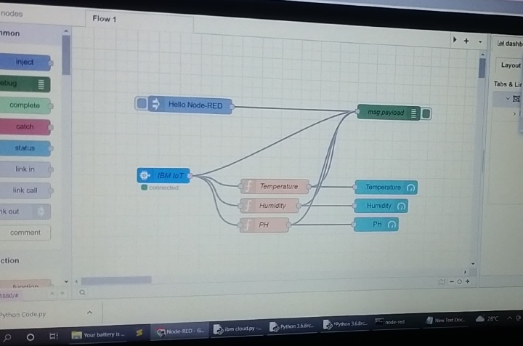

HTTP REQUEST TO COMMUNICATE WITH MOBILE APP

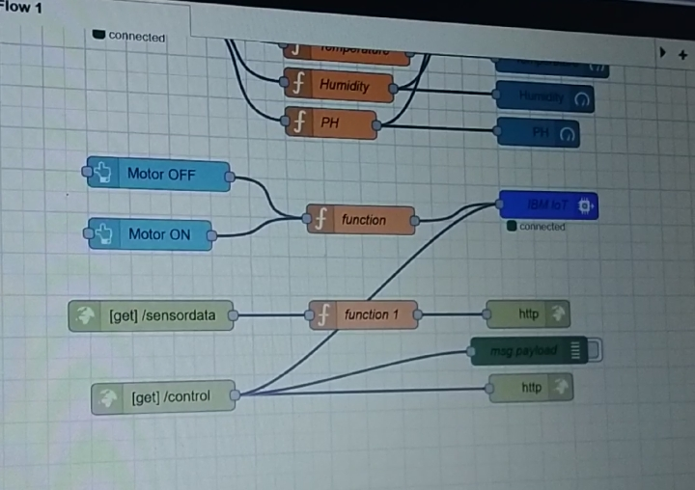

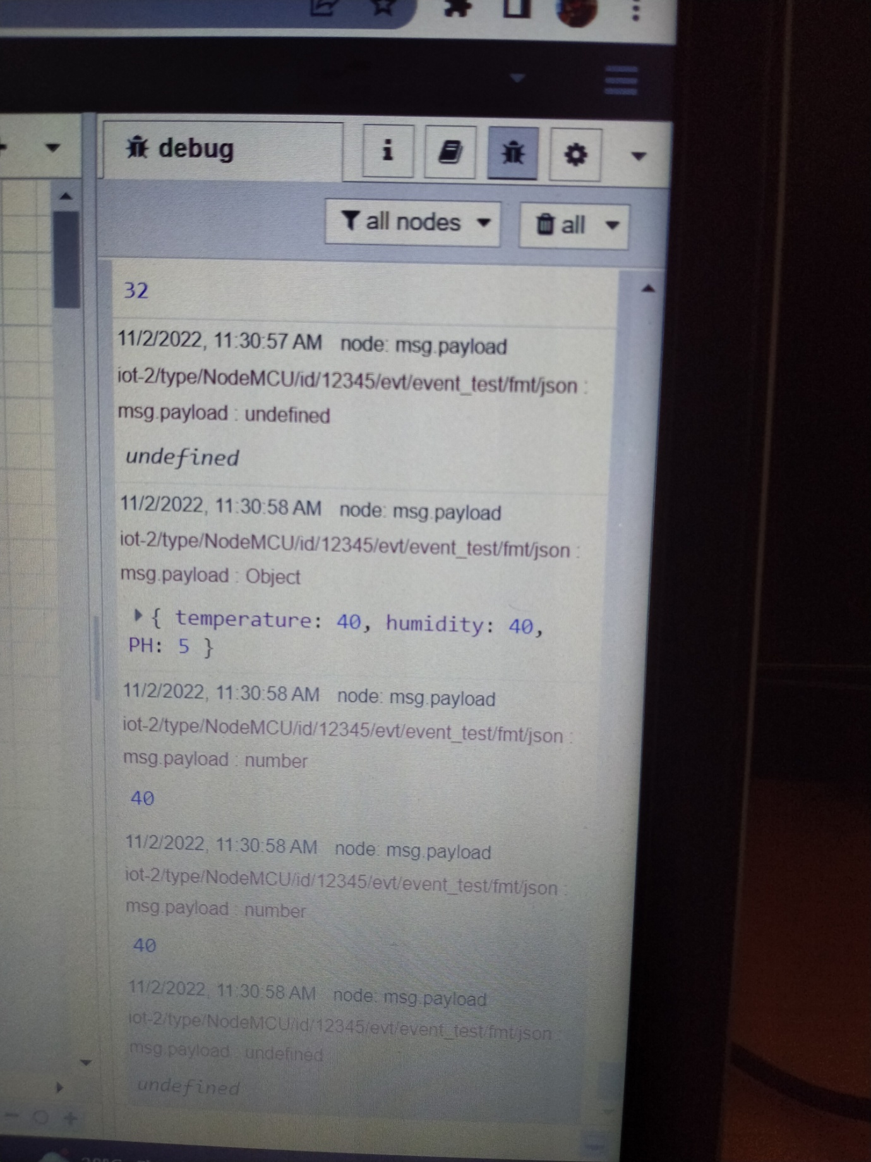

Web application

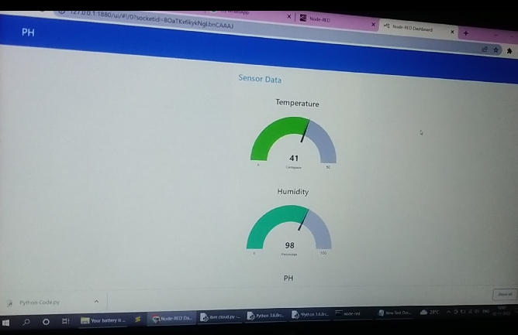

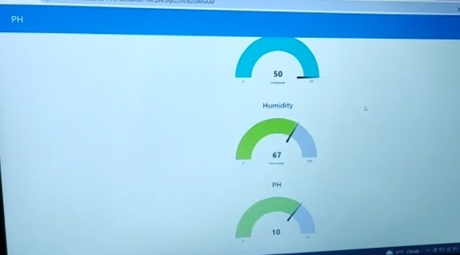

MOBILE APPLICATION

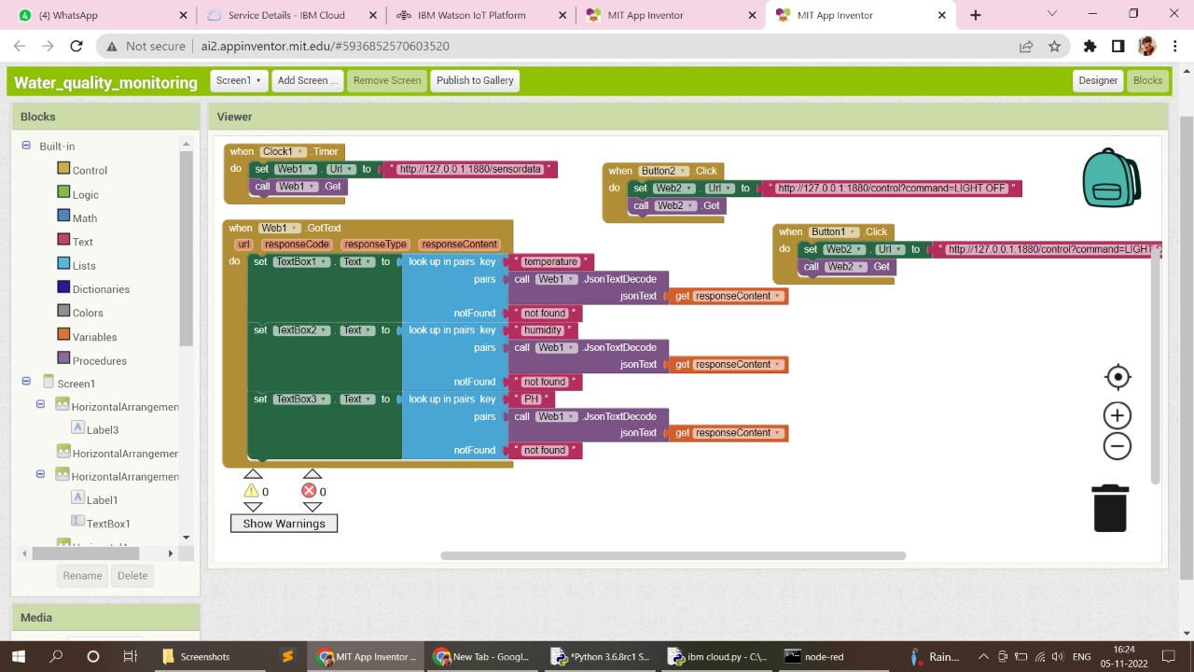

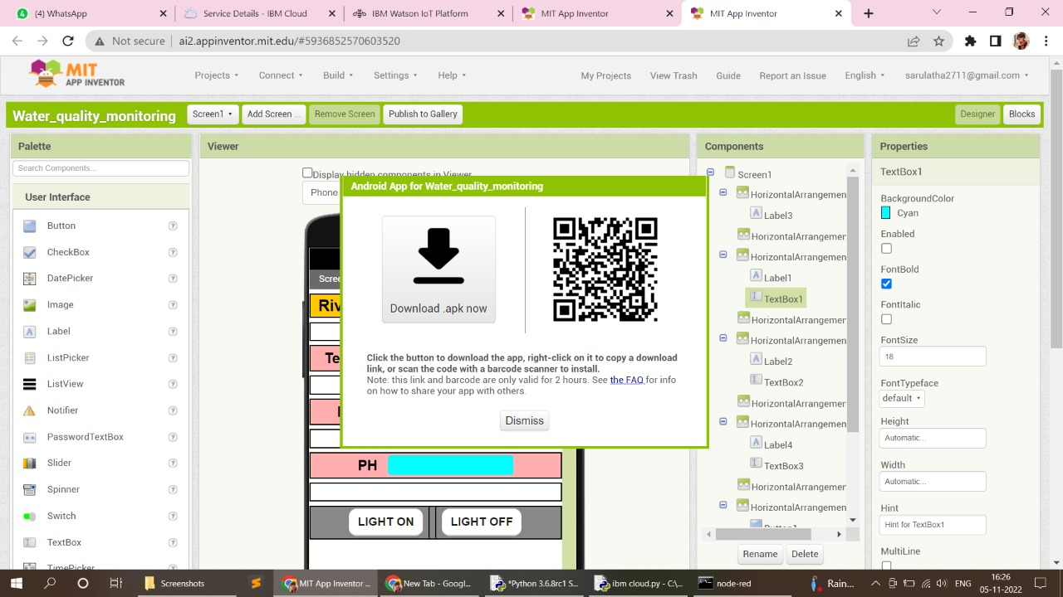

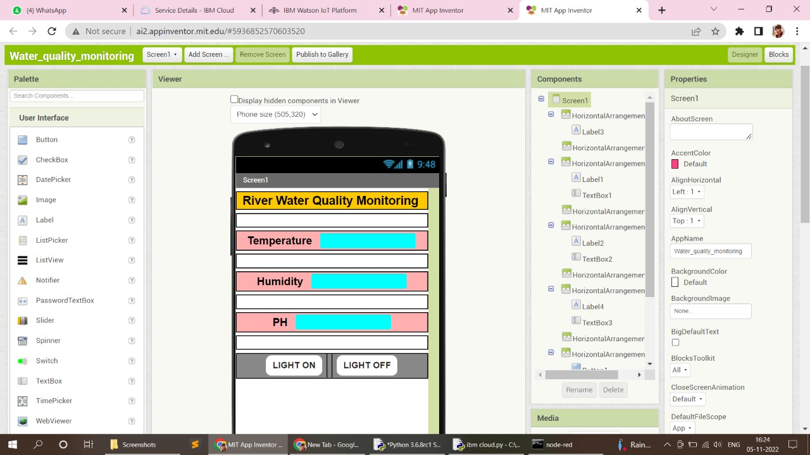

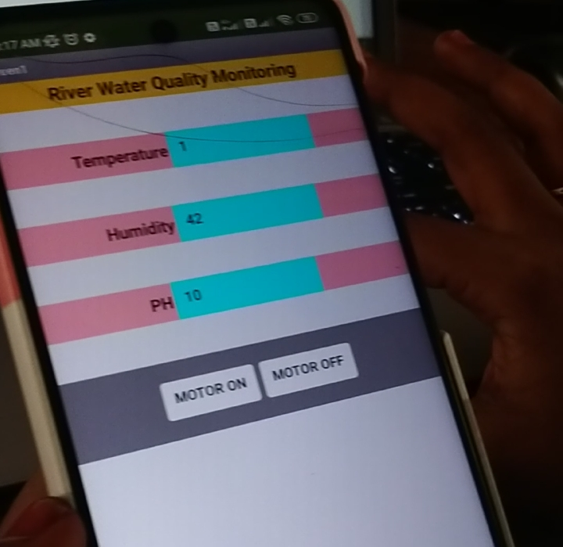

**LITERATURE SURVEY**

**INTRODUCTION**

Water pollution is a foremost global problem which needs ongoing evaluation and adaptation of water resource directorial principle at the levels of international down to individual wells. It has been studied that water pollution is the leading cause of mortalities and diseases worldwide. The records show that more than 14,000 people die daily worldwide due to water pollution. In many developing countries, dirty or contaminated water is being used for drinking without any proper prior treatment. One of the reasons for this happening is the ignorance of public and administration and the lack of water quality monitoring system which makes serious health issues. The design of Wireless Sensor Network (WSN) that assists to monitor the quality of water with the support of information sensed by the sensors dipped in water is depicted. Using different sensors, this system can collect various parameters from water, such as pH, dissolved oxygen, turbidity, conductivity, temperature, and so on. The rapid development of WSN technology provides a novel approach to real-time data acquisition, transmission, and processing. The clients can get ongoing water quality information from far away. Though IOT is still under applied in the field of environment it has huge potential. It can be applied to detect forest fire and early earthquake, reduce air population, monitor snow level, prevent landslide, and avalanche etc. Moreover, it can be implemented in the field of water quality monitoring and controlling system. Water quality monitoring has gained more interest among researchers in this twenty-first century.

|  |  |
| --- | --- |
|  |  |

**PROPOSED METHOD**

Current water quality monitoring system is a manual system with a monotonous process and is very time-consuming. This project proposes a sensor – based water Quality monitoring system. The main components of Wireless Sensor Network(WSN)include a microcontroller for processing the system, communication system for inter and intra node communication and several sensors. Real-time data access can be done by using remote monitoring and Internet of Things (IOT) technology. Data collected at the apart site can be displayed in a visual format on a server PC with the help of Spark streaming analysis through Spark MLlib, Deep learning neural network models, Belief Rule Based (BRB) system and is also compared with standard values. If the acquired value is above the threshold value automated warning SMS alert will be sent to the agent. The uniqueness of our proposed paper is to obtain the water monitoring system with high frequency, high mobility, and low powered. Therefore, our proposed system will immensely help Bangladeshi population to become conscious against contaminated water as well as to stop polluting the water.

|  |  |
| --- | --- |
|  |  |

**RELATED WORKS**

Different authors have proposed distinguished models to check water quality by analyzing the parameters such as temperature, pH and conductivity, and so on. Stephen Brosnan investigated a WSN to collect real time water quality parameters (WQP). Quio Tie-Zhn, developed online water quality monitoring system based on GPRS/GSM. The information was sent by means of GPRS network, which helped to check remotely the WQP. KamalAlameh presented web based WSN for monitoring water pollution using ZigBee and WiMAX networks. The system collected, processed measured data from sensors, and directed through ZigBee gateway to the web server by means of WiMAX network to monitor quality of water from large distances in real time. Dong He developed WQM system based on WSN. The remote sensor was based on ZigBee network. WSN tested WQP and sent data to Internet using GPRS. With the help of Web, information was gathered at remote server. Vijayakumar et al., designed a lowcost system design for real time water quality monitoring in IoT utilizes sensors to check many important physical and chemical parameters of water. The parameters such as turbidity, temperature, pH, dissolved oxygen conductivity of water can be measured. In our project, we proposed a water quality monitoring system based on IoT.

**CONCLUSIONS AND FUTURE WORKS**

Real-time monitoring of water quality by using IoT integrated Big Data Analytics will immensely help people to become conscious against using contaminated water as well as to stop polluting the water. The research is conducted focusing on monitoring river water quality in real-time. Therefore, IoT integrated big data analytics is appeared to be a better solution as reliability, scalability, speed, and persistence can be provided. During the project development phase an intense comparative analysis of real-time analytics technologies such as Spark streaming analysis through Spark MLlib, Deep learning neural network models, and Belief Rule Based (BRB) system will be conducted. This research would recommend conducting systematic experimentation of the proposed technologies in diverse qualities of river water in Bangladesh. Due to the limitation of the budget, we only focus on measuring the quality of river water parameters. This project can be extended into an efficient water management system of a local area. Moreover, other parameters which wasn’t the scope of this project such as total dissolved solid, chemical oxygen demand and dissolved oxygen can also be quantified. So the additional budget is required for further improvement of the overall system.

**AUTHOR CONTRIBUTIONS**

All the authors have accepted responsibility for the entire content of this submitted manuscript and approved the submission. MSUC, TBE, SG, AP, MMA, NA, and MSH carried out the study design, performed the experiments, data collection, data interpretation, and statistical analysis. Authors MSUC, TBE, and AP collected the water samples. Authors SGand AP has arranged the software simulation study. Authors TBE and MSH has arranged the biological study. MSUC, TBE, SG, AP, and MSH designed and planned the studies, supervised the experiments. MSH also acted for all correspondences. MSUC,TBE,SG, AP, MMA, NA, and MSH participated in the manuscript draft and has thoroughly checked and revised the manuscript for necessary changes in format, grammar and English standard. KA checked the format, grammar and revised the manuscript. All authors read and agreed the final version of the manuscript.

**FUNDING**

This research has been funded by Prof.Dr. S. K. S. Hazari, Vice-Chancellor, BGC Trust University Bangladesh under the special allocation.

**REFERENCES**

[1] K. S. Adu-Manu, C. Tapparello, W. Heinzelman, F. A. Katsriku, and J.-D. Abdulai, "Water quality monitoring using wireless sensor networks: Current trends

and future research directions," ACM Transactions on Sensor Networks (TOSN), vol. 13, p. 4, 2017.

[2] B. Chen, Y. Song, T. Jiang, Z. Chen, B. Huang, and B. Xu, "Real-time estimation of population exposure to PM2.5 using mobile- and station-based big data,"

Int J Environ Res Public Health, vol. 15, Mar 23 2018.

[3] B. Paul, "Sensor based water quality monitoring system," BRAC University, 2018.

[4] K. Andersson and M. S. Hossain, "Smart Risk Assessment Systems using Belief-rule-based DSS and WSN Technologies", in 2014 4th International Conference

on Wireless Communications, Vehicular Technology, Information Theory and Aerospace and Electronic Systems, VITAE 2014 : Co-located with Global

Wireless Summit, Aalborg, Denmark 11-14 May 2014, 2014

IDEATION



    
    
    

